Project Report: Automatic Plant Watering System (Arduino)

1. Project Goal
The goal of this project is to create a simple automatic plant watering system that measures soil moisture and turns on a water pump when needed.
The system should:
- Show soil moisture on an LCD display.
- Automatically turn on a pump via a relay when moisture is low.
- Be safe and easy to assemble.

- 2. Project Components
Component | Quantity | Description
Arduino Uno | 1 | Microcontroller controlling all devices
I²C LCD 16x2 | 1 | Display showing moisture level
Soil Moisture Sensor | 1 | Measures soil moisture in percentage
5V Relay | 1 | Switches pump power
5V Water Pump | 1 | Waters the plants
Wires | – | For connecting all parts
5V Power Supply | 1 | For the pump (can be separate)

3. Wiring Diagram
Text summary:
- LCD: VCC → 5V, GND → GND, SDA → A4, SCL → A5
- Sensor: VCC → 5V, GND → GND, OUT → A0
- Relay: VCC → 5V, GND → GND, IN → D8
- Pump: +5V → through relay → pump, - → GND (external supply)
- Common GND: Arduino + power supply + relay + sensor
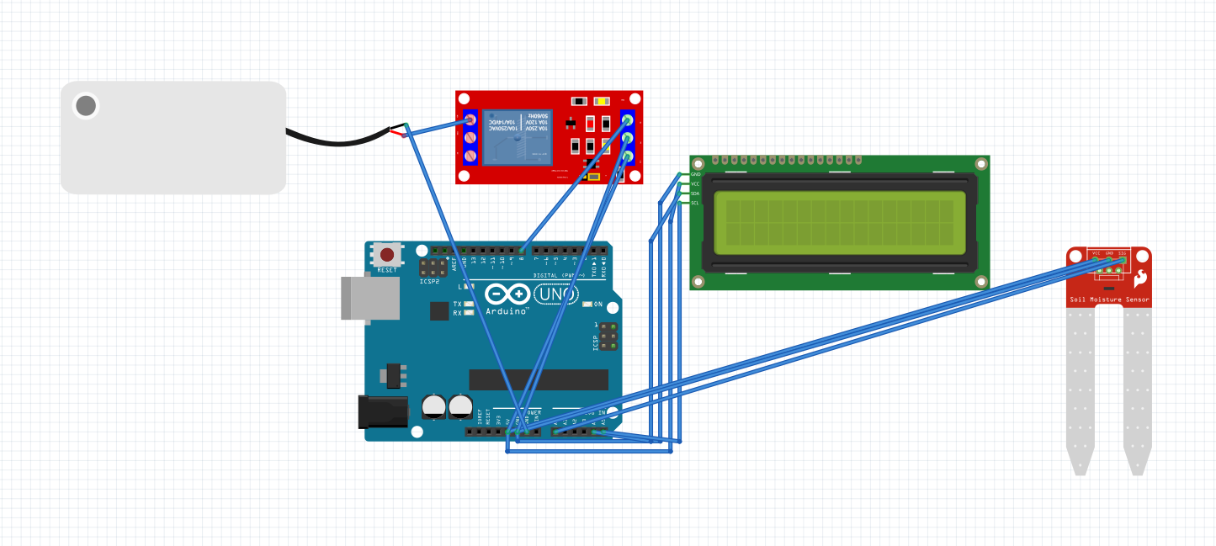

4. How the System Works
- Arduino reads the moisture sensor every second.
- The raw value is converted into a percentage.
- If moisture drops below a set threshold (e.g., 30%), Arduino turns on the relay, powering the pump.
- The pump runs until moisture reaches the upper threshold (e.g., 40%) or until a maximum watering time (e.g., 30 seconds) is reached.
- Moisture levels and raw data are shown on the LCD.
- Data is also sent to the Serial Monitor for debugging.

5. Component Specifications
- Arduino Uno: 5V, up to 40 mA per pin, USB max 500 mA
- I²C LCD 16x2: 5V, ~20 mA
- Soil Moisture Sensor: Analog, 0–1023, capacitive recommended for durability
- 5V Relay: Coil ~70–100 mA, active LOW
- 5V Water Pump: Current depends on model (0.2–1 A for mini pumps)
- 5V Power Supply: Must provide current ≥ pump + relay + safety margin

6. Real-Time Operation
- Arduino works in real-time: checks moisture every second.
- Pump control uses hysteresis to avoid frequent on/off cycles.
- LCD shows live data; Serial Monitor is used for real-time monitoring.

Project Source Code
- #include <LiquidCrystal_I2C.h>
// Инициализация дисплея
LiquidCrystal_I2C lcd(0x27, 16, 2);
// Пины подключения
const int sensorPin = A0; // Датчик влажности
const int relayPin = 7; // Реле
// Калибровочные значения (ПОМЕНЯЛИ МЕСТАМИ!)
int dryValue = 320; // Значение в СУХОЙ почве (маленькое число)
int wetValue = 620; // Значение во ВЛАЖНОЙ почве (большое число)
int humidityThreshold = 30; // Порог влажности в % (если < 30% - ВКЛЮЧИТЬ насос)
// Переменные для полива
bool isWatering = false;
unsigned long wateringStartTime = 0;
const unsigned long wateringDuration = 5000; // 5 секунд полива
void setup() {
Serial.begin(9600);
// Инициализация дисплея
lcd.init();
lcd.backlight();
lcd.setCursor(0, 0);
lcd.print("Auto Watering");
lcd.setCursor(0, 1);
lcd.print("System Ready!");
delay(2000);
lcd.clear();
// Настройка реле
pinMode(relayPin, OUTPUT);
digitalWrite(relayPin, HIGH); // Выключить реле
Serial.println("System started - FIXED VERSION");
}
void loop() {
// Чтение датчика
int sensorValue = analogRead(sensorPin);
// Конвертация в проценты (ПРАВИЛЬНАЯ логика)
// Чем МЕНЬШЕ значение датчика - тем СУШЕ
// Чем БОЛЬШЕ значение датчика - тем ВЛАЖНЕЕ
int humidityPercent = map(sensorValue, dryValue, wetValue, 0, 100);
humidityPercent = constrain(humidityPercent, 0, 100);
// Вывод на дисплей
lcd.setCursor(0, 0);
lcd.print("Moisture: ");
lcd.print(humidityPercent);
lcd.print("% ");
// Отладочная информация в Serial
Serial.print("Sensor: ");
Serial.print(sensorValue);
Serial.print(" | Humidity: ");
Serial.print(humidityPercent);
Serial.print("% | Status: ");
// Логика полива (ИСПРАВЛЕННАЯ)
if (isWatering) {
lcd.setCursor(0, 1);
lcd.print("WATERING... ");
Serial.println("WATERING");
// Проверяем время полива
if (millis() - wateringStartTime >= wateringDuration) {
stopWatering();
isWatering = false;
lcd.setCursor(0, 1);
lcd.print("Watering Done!");
delay(2000);
}
} else {
// ЕСЛИ влажность МЕНЬШЕ порога - ВКЛЮЧАЕМ полив
if (humidityPercent > humidityThreshold) {
lcd.setCursor(0, 1);
lcd.print("TOO DRY! PUMP ON");
Serial.println("TOO DRY - STARTING PUMP");
delay(1000);
startWatering();
isWatering = true;
wateringStartTime = millis();
} else {
lcd.setCursor(0, 1);
lcd.print("Soil OK :) ");
Serial.println("OK");
}
}
delay(1000);
}
void startWatering() {
digitalWrite(relayPin, LOW); // Включить реле
Serial.println("PUMP: ON");
}
void stopWatering() {
digitalWrite(relayPin, HIGH); // Выключить реле
Serial.println("PUMP: OFF");
}

